

**Data Base Systems Mini Project**

A report submitted to the

Department of Electrical and Information Engineering

Faculty of Engineering

University of Ruhuna Sri Lanka

On 9th of April 2024

In completing an assignment for the module

EE4350 Data Base systems

By:

Group 28

|  |  |
| --- | --- |
| EG/2021/4549 | HERATH H.M.L.B. |
| EG/2021/4550 | HERATH H.M.L.T. |
| EG/2021/4556 | HEWAWASAM A.D.K. |

Contents

Chapter 1 - Requirement Analysis 4

1.1. Functional Requirements 4

1.2. Data Requirements 4

Chapter 2 - Conceptual Design 7

Chapter 3 - Implementation 8

3.1. Table implementation 8

3.2. Creating Foreign key constraint 13

3.3. Inserting data for tables 14

3.4. Update and delete 19

Chapter 4 - Transactions 24

Chapter 5 - Tuning 35

**List of figures**

Figure 2.1:ER diagram of the league management database management system 8

Figure 3.1: Create League Table. 9

Figure 3.2: Create Team Table. 9

Figure 3.3: Create Table Player. 10

Figure 3.4: Create Table Sponsor. 10

Figure 3.5: Create Table League_Sponsor. 11

Figure 3.6: Create Table Team_Sponsor. 11

Figure 3.7: Create Table Referee. 11

Figure 3.8: Create Table Venue. 12

Figure 3.9: Create Table Game. 12

Figure 3.10: Create Table Game_Team. 12

Figure 3.11: Create Table Game_Referee. 13

Figure 3.12: Create Table Player_Stat. 13

Figure 3.13: Create Table Team_Stat. 13

Figure 3.14: Create Foreign Key Constraints - I. 14

Figure 3.15: Create Foreign Key Constraints - II. 14

Figure 3.16: Tables in the League_Management_System. 15

Figure 3.17: Inserting Values to League Table. 15

Figure 3.18: Inserting Values to Team Table. 15

Figure 3.19: Inserting Values to Player Table. 16

Figure 3.20: Inserting Values to Sponsor Table. 16

Figure 3.21: Inserting Values to League_Sponsor Table. 16

Figure 3.22: Inserting Values to Team_Sponsor Table. 16

Figure 3.23: Inserting Values to Referee Table. 17

Figure 3.24: Inserting Values to Venue Table. 17

Figure 3.25: Inserting Values to Game Table. 17

Figure 3.26: Inserting Values to Game_Referee Table. 18

Figure 3.27: Inserting Values to Player_Stat. 18

Figure 3.28: Inserting Values to Team_Stat Table. 19

Figure 3.29: Updating League Table. 20

Figure 3.30: Updating Team Table. 20

Figure 3.31: Updating Player Table. 21

Figure 3.32: Updating Sponsor Table. 21

Figure 3.33: Updating Referee Table. 22

Figure 3.34: Updating Venue Table. 22

Figure 3.35: Updating Game Table. 23

Figure 3.36: Updating Game_Team Table. 23

Figure 3.37: Updating Player_Stat Table. 24

Figure 3.38: Updating Team_Stat Table. 24

Figure 4.1: The SELECT Operation. 25

Figure 4.2: The PROJECT Operation. 25

Figure 4.3: The CARTESIAN PRODUCT - I. 26

Figure 4.4: The CARTESIAN PRODUCT - II. 27

Figure 4.5:The CARTESIAN PRODUCT - III. 27

Figure 4.6: Creating USER VIEWS. 28

Figure 4.7: Operation Renaming. 28

Figure 4.8: Aggregation (Average). 28

Figure 4.9: Using LIKE Keyword. 29

Figure 4.10: Union. 30

Figure 4.11: Intersection. 30

Figure 4.12: Set Difference. 30

Figure 4.13: Division. 31

Figure 4.14: INNER JOIN. 31

Figure 4.15: NATURAL JOIN. 32

Figure 4.16: LEFT OUTER JOIN. 32

Figure 4.17: RIGHT OUTER JOIN. 33

Figure 4.18: FULL OUTER JOIN. 33

Figure 4.19: OUTER UNION. 34

Figure 4.20: Nested Query - I. 35

Figure 4.21: Nested Query - II. 35

Figure 4.22: Nested Query - III. 35

# Requirement Analysis

## Functional Requirements

All of the program's desired operations are incorporated step-by-step in accordance with this chapter. This database accomplishes the following things in order to do that.

• Data retrieval

• Ability to alter the database's content at any time

• Capable of completing potential data gaps or missing data

• Capability to edit data that has already been entered into the database

• The ability to add comments to data when the data is incomplete or ambiguous.

• The capacity to provide data with enhanced performance

This schema is created to represent the sport league and all the needed and maximum number of entities of this schema have been covered. They are league, team, player, sponsor, league sponsor, team sponsor, referee, venue, game, game team, game referee, player stat, team stat.. All the needed data for the schema shown in this database.

## Data Requirements

The attributes of each entity are shown below

League

* League_ID
* League_name
* Sport
* Start_date
* End_date
* Location

Team

* Team_ID
* Team_name
* League_ID
* City

Player

* Player_ID
* First_name
* Last_name
* Team_ID
* Birthday
* Position
* Jersey_number

Sponser:

* Sponser_ID
* Company_name
* Contact_number
* Email
* Category

League_Sponser:

* League_ID
* Sponsor_ID

Team_Sponser:

* Team_ID
* Sponsor_ID

Referee:

* Referee_ID
* First_name
* Last_name
* Contact_number

Venue:

* Venue_ID
* Venue_name
* Capacity
* Country

Game:

* Game_ID
* Venue_ID
* Winning_Team_ID

Game_Team:

* Game_ID
* Team_ID
* Winner_flag

Game_Refree:

* Game_ID
* Refree_ID

Player_Stat:

* Match_ID
* Player_ID
* Goals
* Assists

Team_Stat:

* Match_ID
* Team_ID
* Goals_for
* Goals_against

Also, we are included some important entities and relationships.

They are,

* Weak entities
* Recursive relationship
* Weak entities

There are two weak entities in our ER diagram shown, and we have shown them using a double-line rectangle. Player stat is one of them. It depends on the player entity. The player stat entity does not have a key either. Therefore, we have considered player stat as a weak entity. Another weak entity we have considered is the team stat entity. It does not have a key, and it also totally depends on the team entity. So, we consider team stat to be a weak entity.

* Recursive relationship

Here, we have considered the relationship between the team leader and the members as a recursive relationship as it exist between the same entity. A leader will lead the team, means that he alone will represent each and every one of the team. Therefore, this is a recursive relationship.

# Conceptual Design

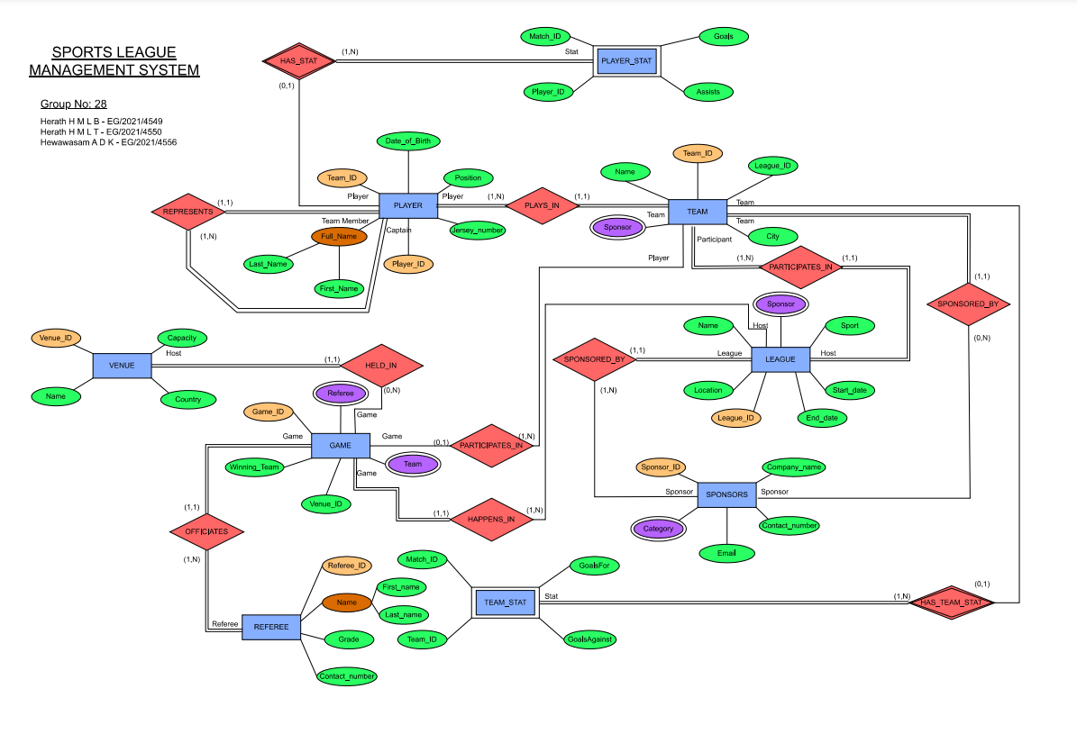

Figure 2.1:ER diagram of the league management database management system

# Implementation

In this chapter, all the screenshots of implemented database model are included.

## Table implementation

* Create table League

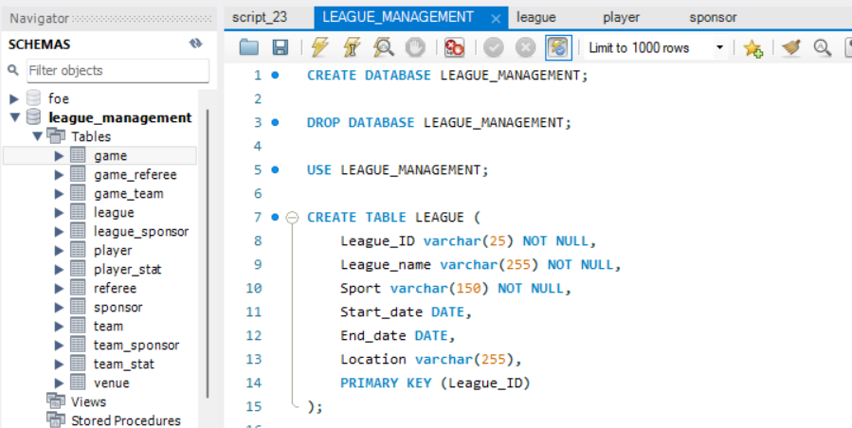

Figure 3.1: Create League Table.

* Create table Team

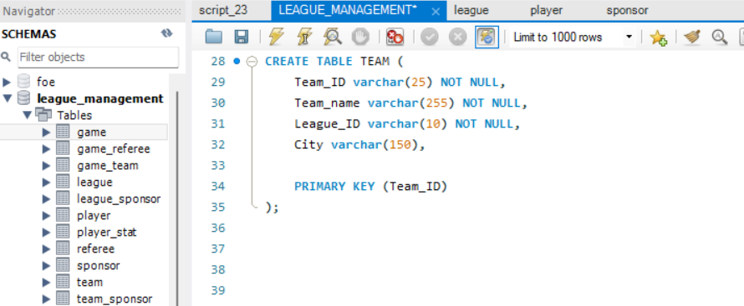

Figure 3.2: Create Team Table.

* Create table Player

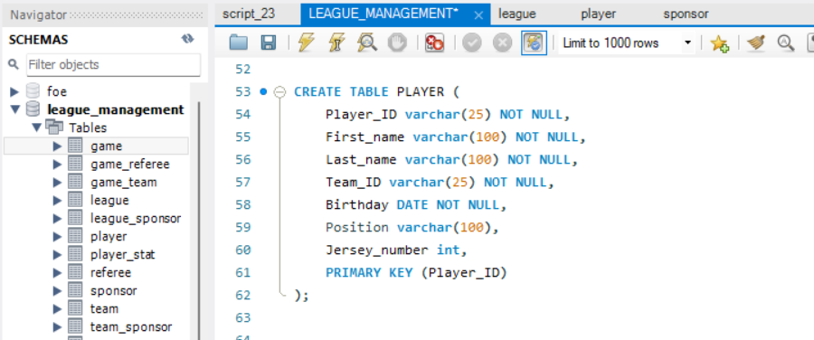

Figure 3.3: Create Table Player.

* Create table Sponsor

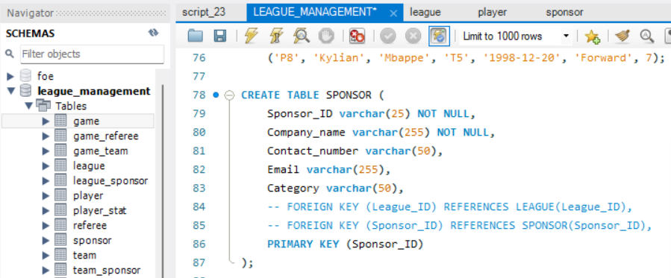

Figure 3.4: Create Table Sponsor.

* Create league_sponser

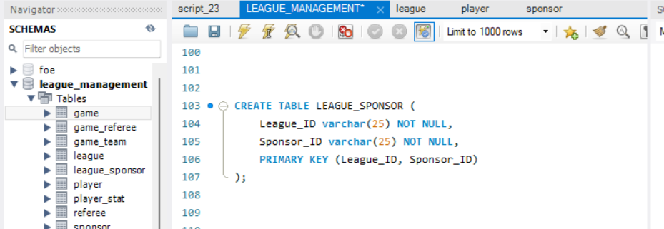

Figure 3.5: Create Table League_Sponsor.

* Create table team_sponser

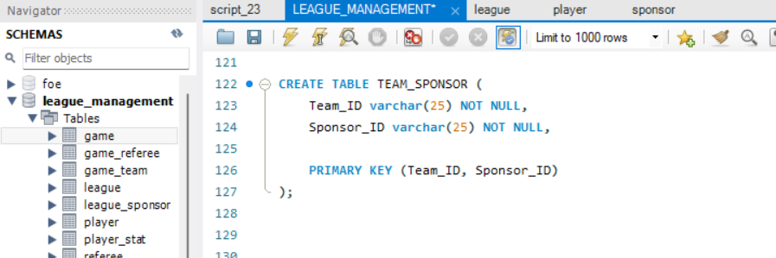

Figure 3.6: Create Table Team_Sponsor.

* Create table referee

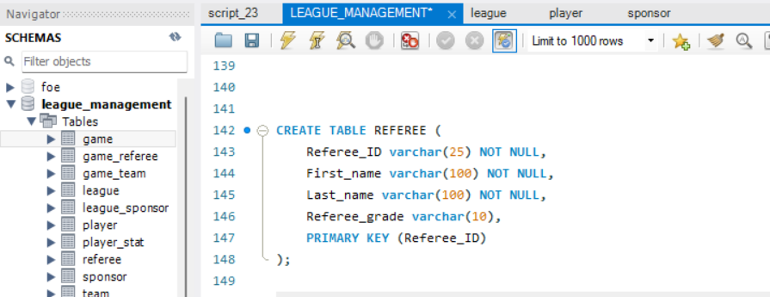

Figure 3.7: Create Table Referee.

* Create table venue

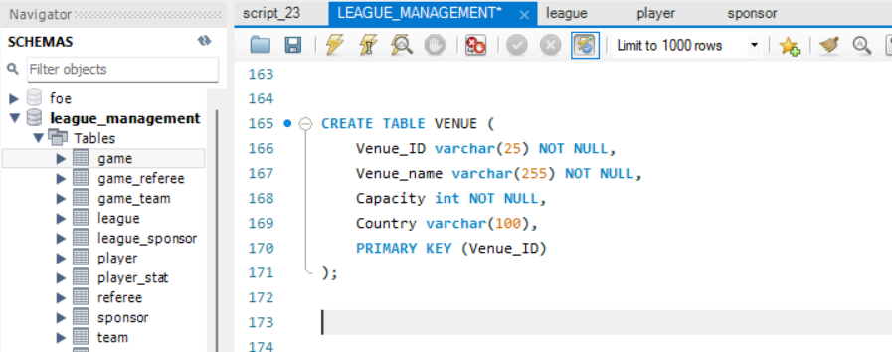

Figure 3.8: Create Table Venue.

* Create table game

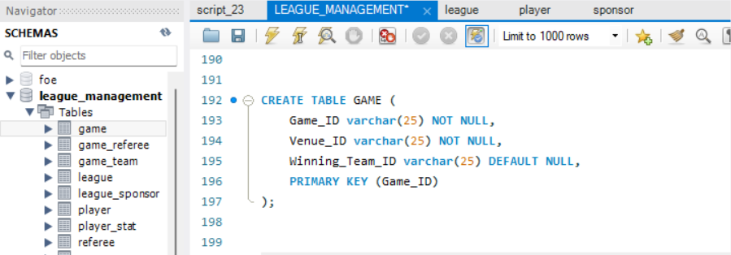

Figure 3.9: Create Table Game.

* Create table game_team

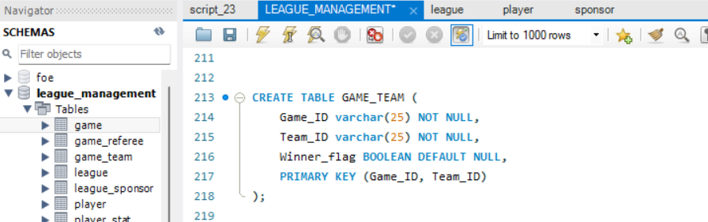

Figure 3.10: Create Table Game_Team.

* Create table game_refree

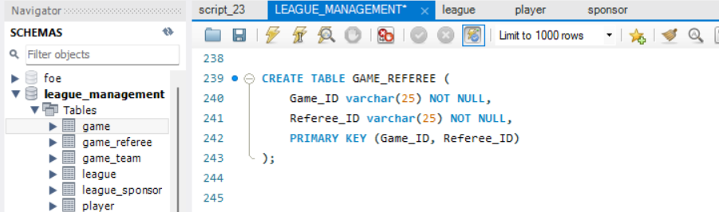

Figure 3.11: Create Table Game_Referee.

* Create player_stat

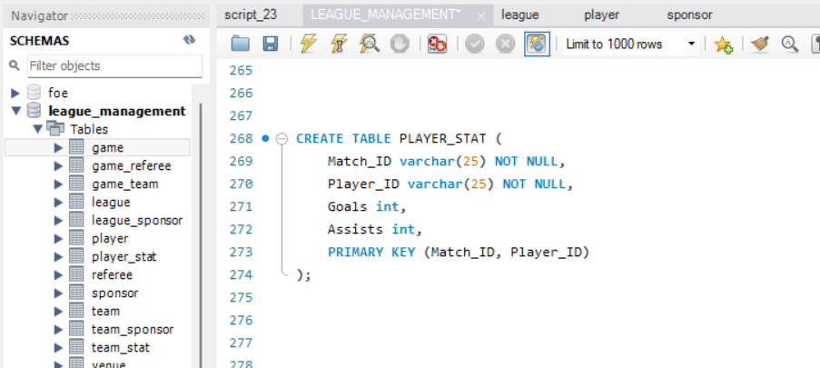

Figure 3.12: Create Table Player_Stat.

* Create team_stat

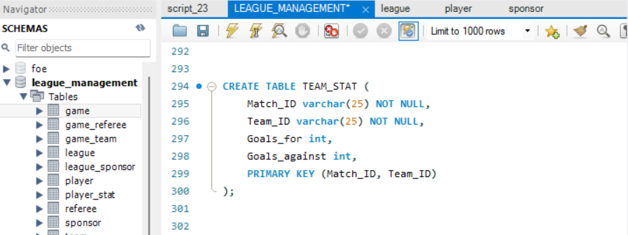

Figure 3.13: Create Table Team_Stat.

## Creating Foreign key constraint

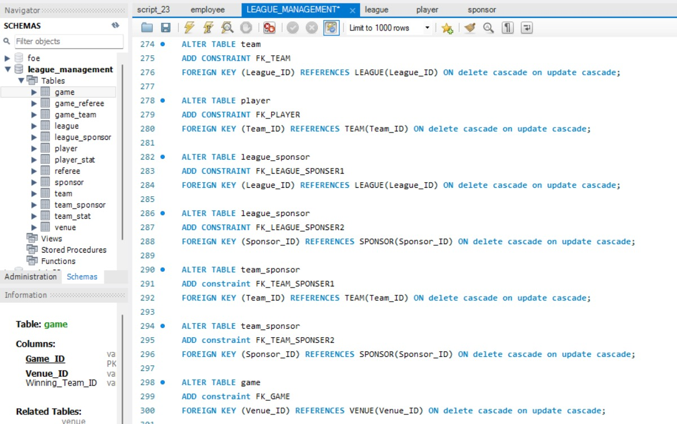

Figure 3.14: Create Foreign Key Constraints - I.

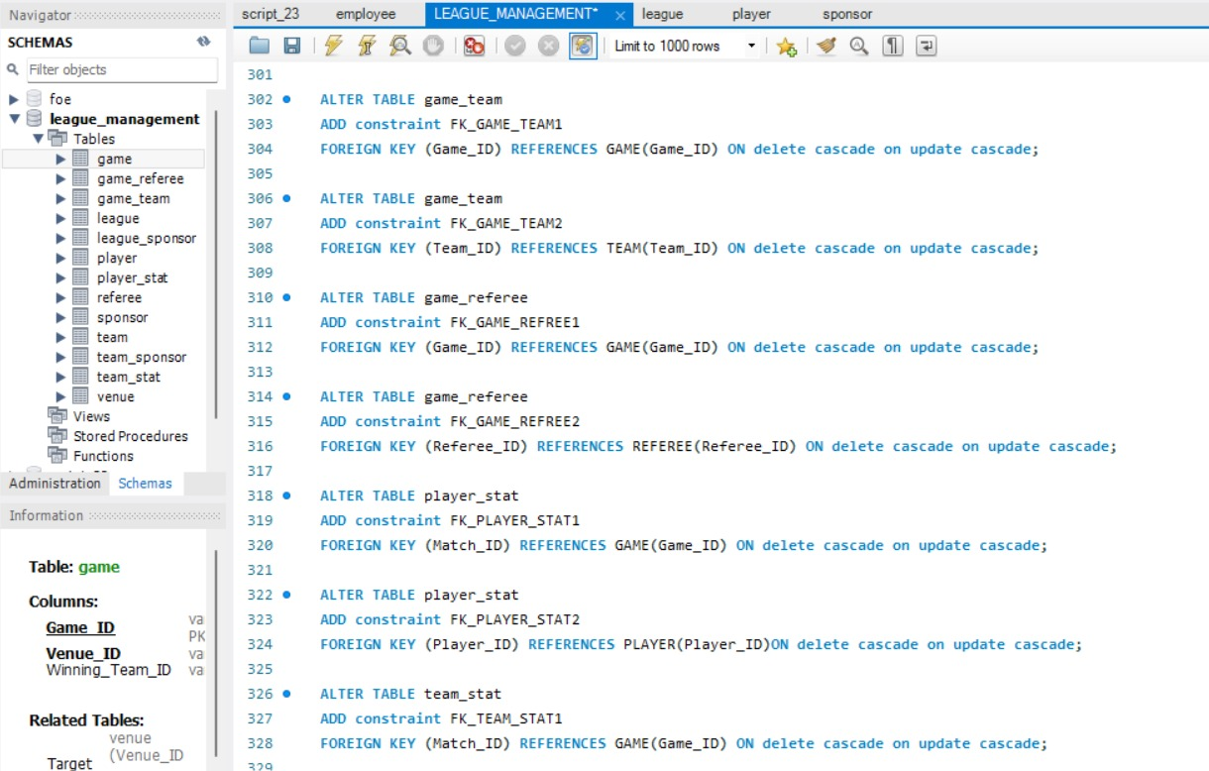

Figure 3.15: Create Foreign Key Constraints - II.

## Inserting data for tables

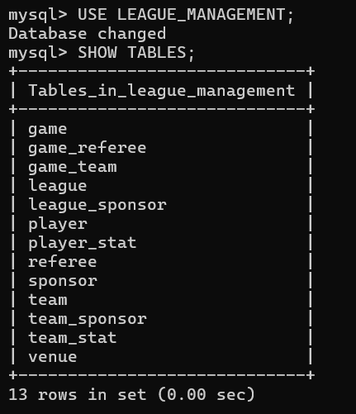

Figure 3.16: Tables in the League_Management_System.

* TABLE LEAGUE

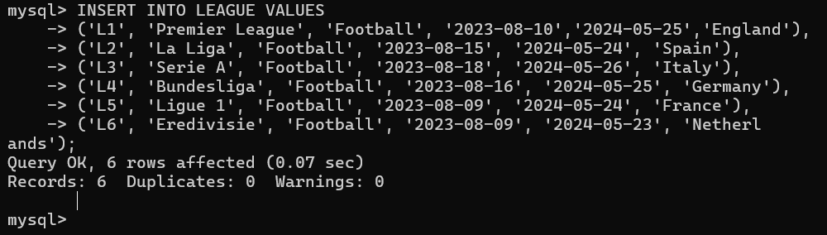

Figure 3.17: Inserting Values to League Table.

* TABLE TEAM

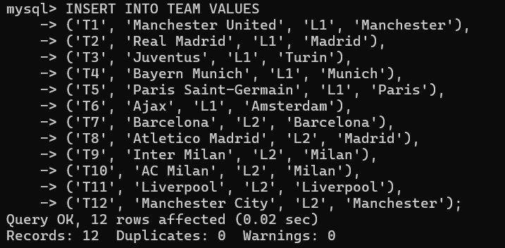

Figure 3.18: Inserting Values to Team Table.

* PLAYER

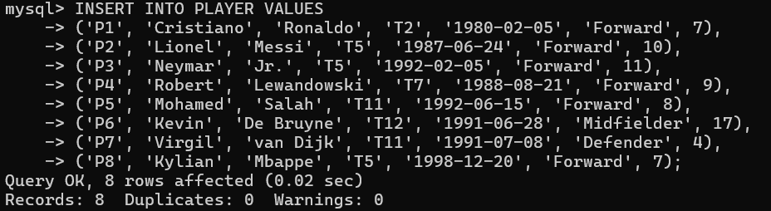

Figure 3.19: Inserting Values to Player Table.

* SPONSOR

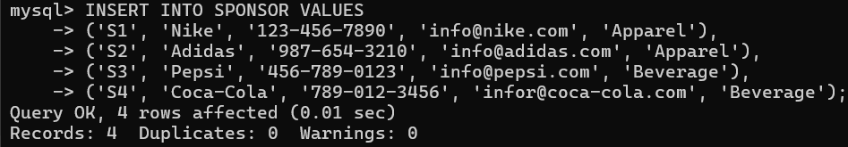

Figure 3.20: Inserting Values to Sponsor Table.

* LEAGUE_SPONSOR

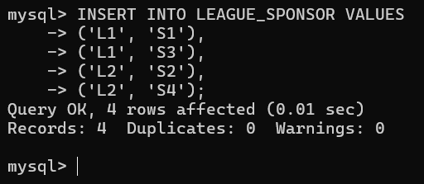

Figure 3.21: Inserting Values to League_Sponsor Table.

* TEAM_SPONSOR

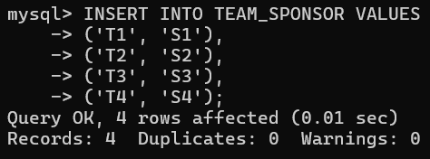

Figure 3.22: Inserting Values to Team_Sponsor Table.

* REFREE

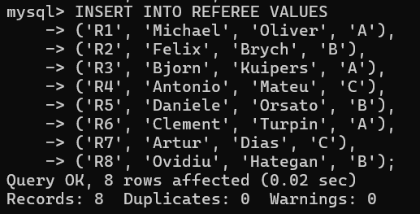

Figure 3.23: Inserting Values to Referee Table.

* VENUE

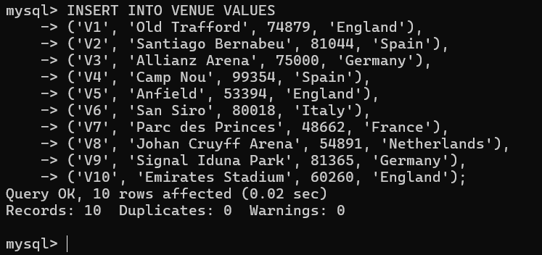

Figure 3.24: Inserting Values to Venue Table.

* GAME

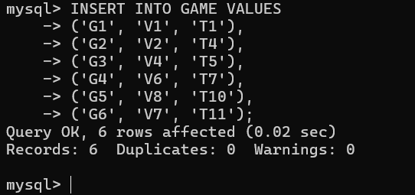

Figure 3.25: Inserting Values to Game Table.

GAME_REFREE

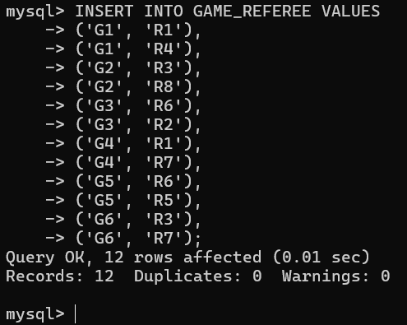

Figure 3.26: Inserting Values to Game_Referee Table.

* PLAYER_STAT

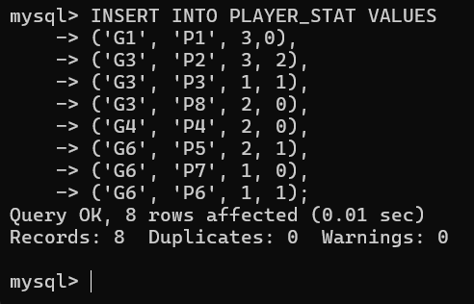

Figure 3.27: Inserting Values to Player_Stat.

* TEAM_STAT

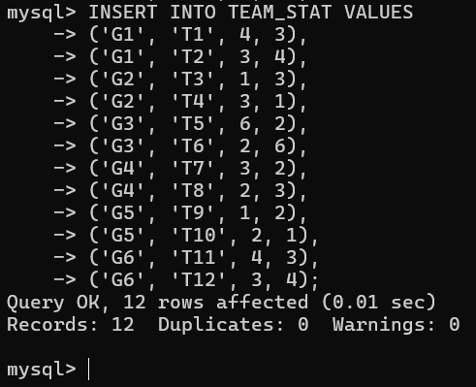

Figure 3.28: Inserting Values to Team_Stat Table.

## Update and delete

* LEAGUE

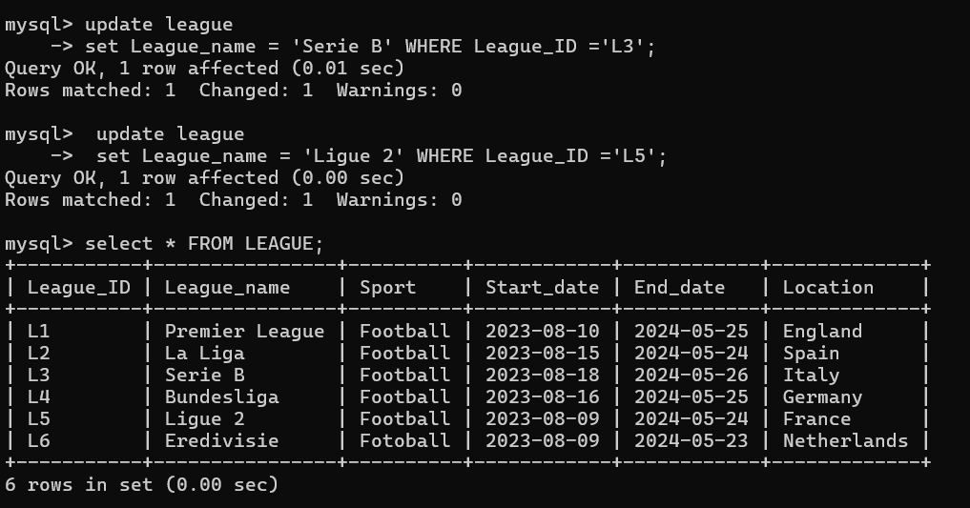

Figure 3.29: Updating League Table.

* TEAM

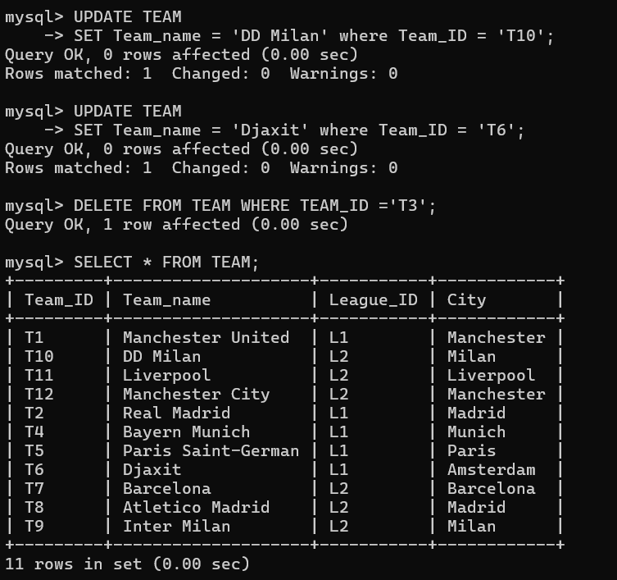

Figure 3.30: Updating Team Table.

* PLAYER

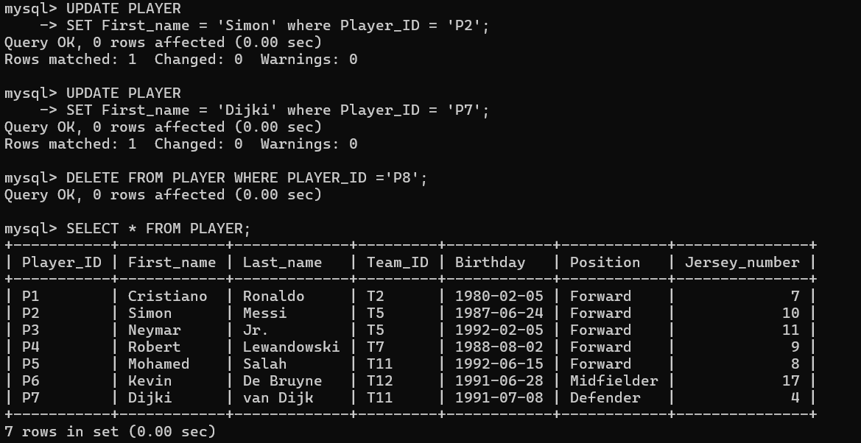

Figure 3.31: Updating Player Table.

* SPONSER

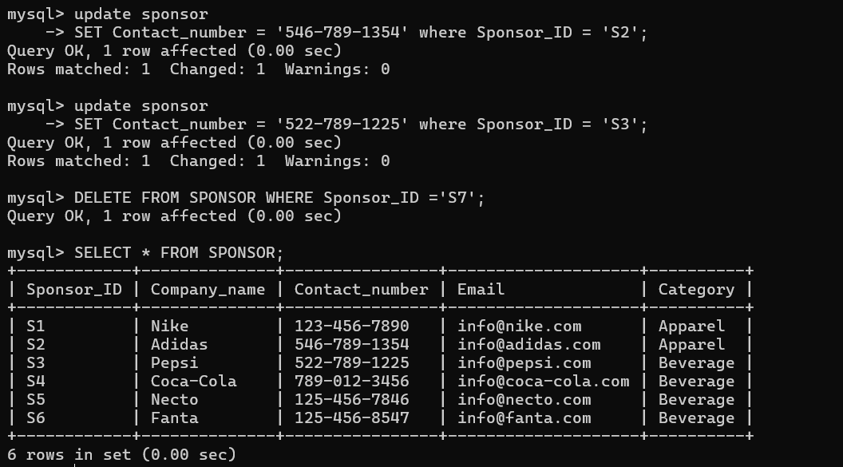

Figure 3.32: Updating Sponsor Table.

* REFEREE

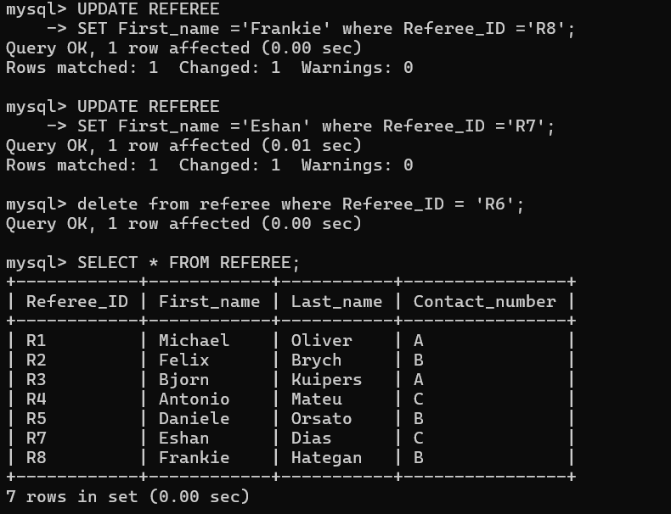

Figure 3.33: Updating Referee Table.

* VENUE

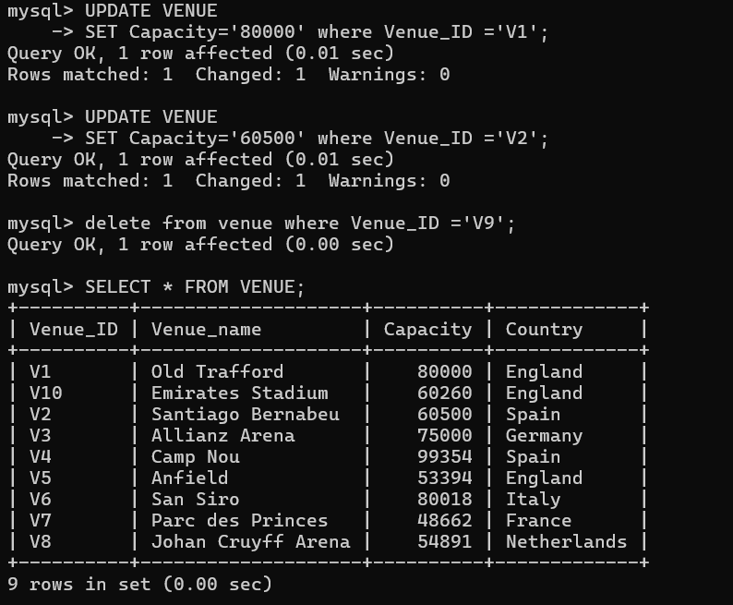

Figure 3.34: Updating Venue Table.

* GAME

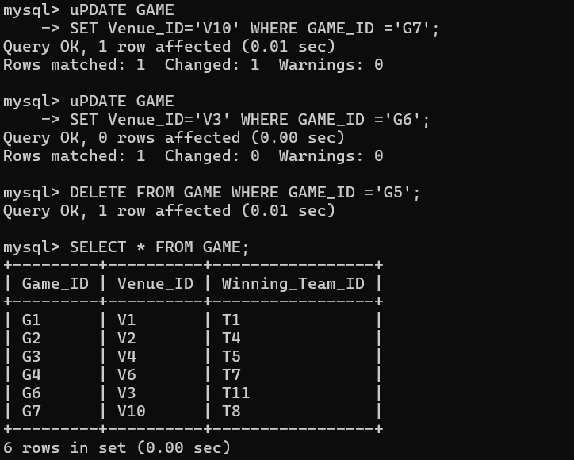

Figure 3.35: Updating Game Table.

* GAME_TEAM

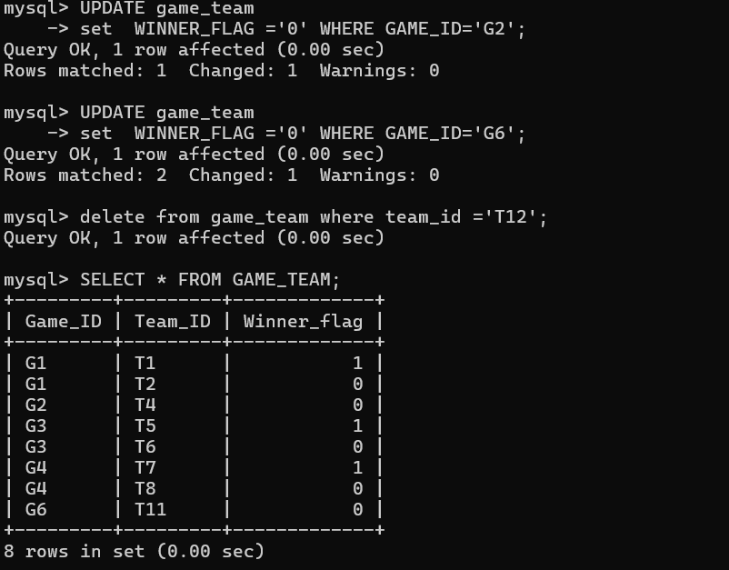

Figure 3.36: Updating Game_Team Table.

* PLAYER_STAT

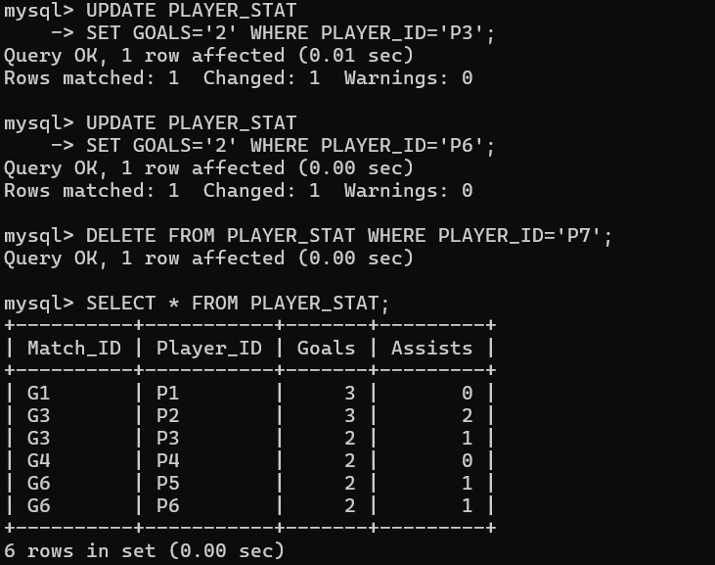

Figure 3.37: Updating Player_Stat Table.

* TEAM_STAT

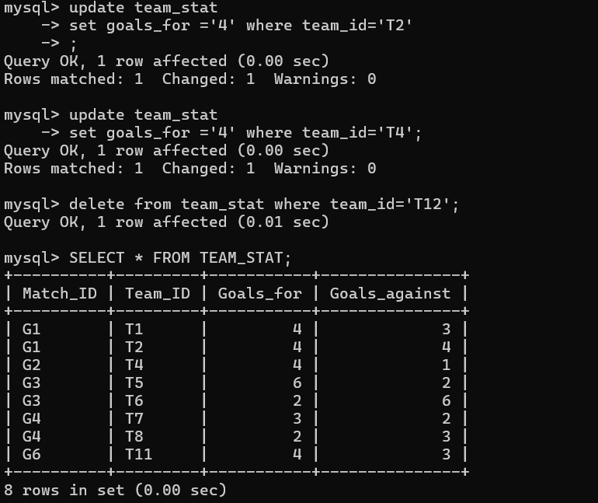

Figure 3.38: Updating Team_Stat Table.

# Transactions

* Select Operation

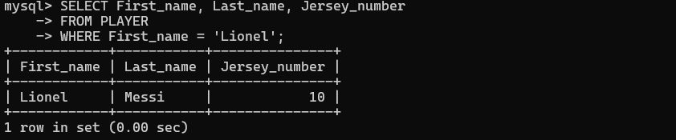

Figure 4.1: The SELECT Operation.

* Project Operation

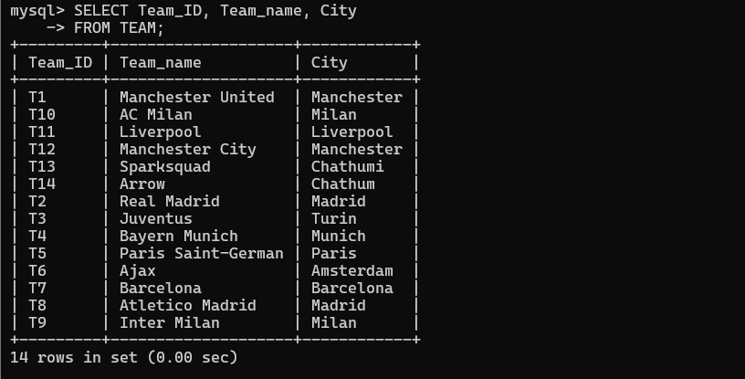

Figure 4.2: The PROJECT Operation.

* Cartesian product

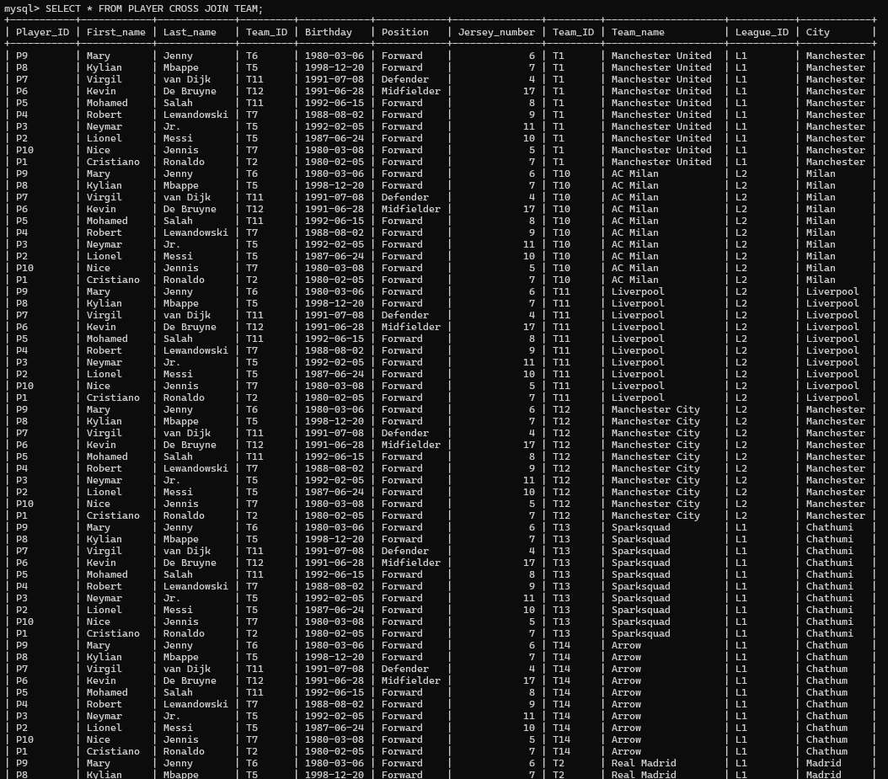

Figure 4.3: The CARTESIAN PRODUCT - I.

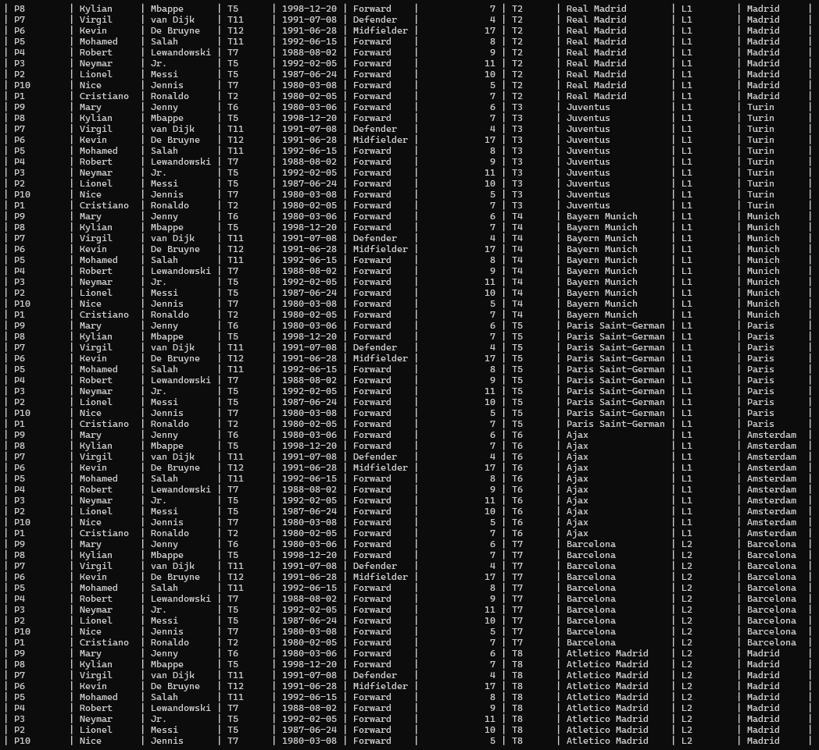

Figure 4.4: The CARTESIAN PRODUCT - II.

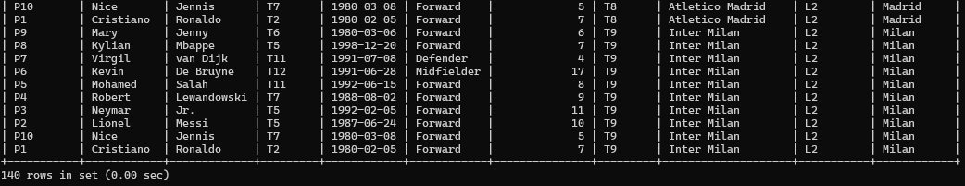

Figure 4.5:The CARTESIAN PRODUCT - III.

Creating a user view

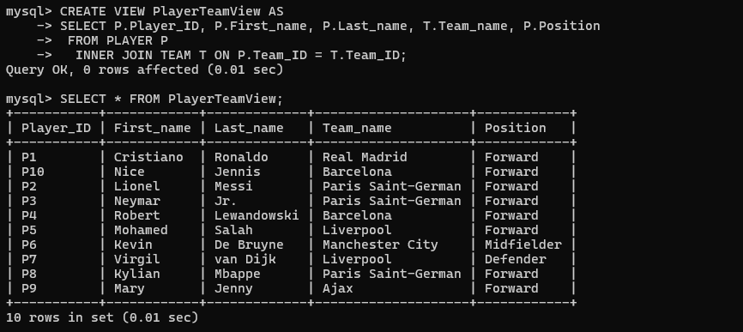

Figure 4.6: Creating USER VIEWS.

* Renaming Operation

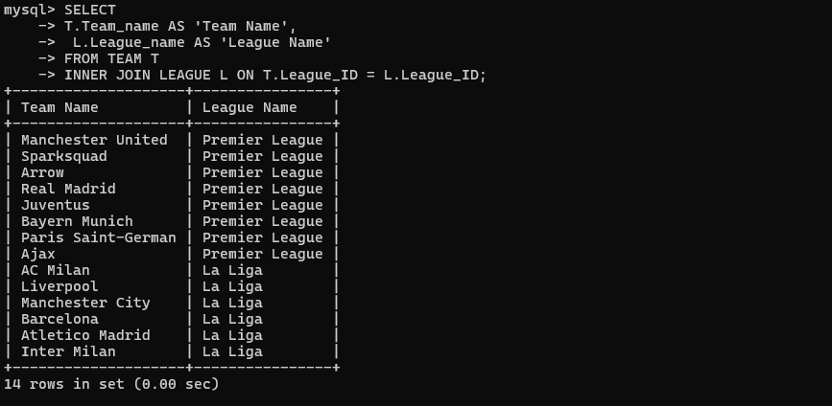

Figure 4.7: Operation Renaming.

* Aggregation (Average function)

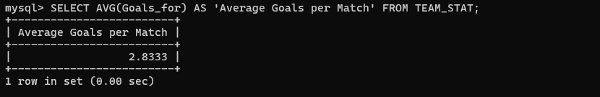

Figure 4.8: Aggregation (Average).

* Like key word

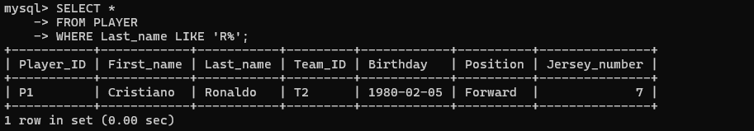

Figure 4.9: Using LIKE Keyword.

* **Complex Queries**
* Union

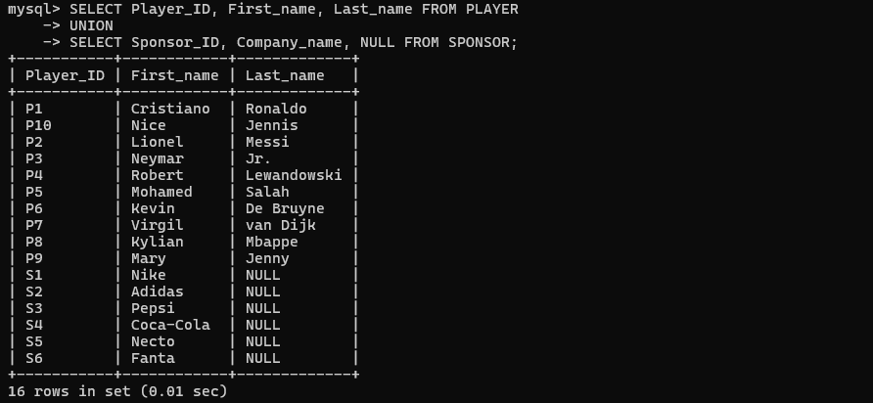

Figure 4.10: Union.

* Intersection



Figure 4.11: Intersection.

* Set Difference

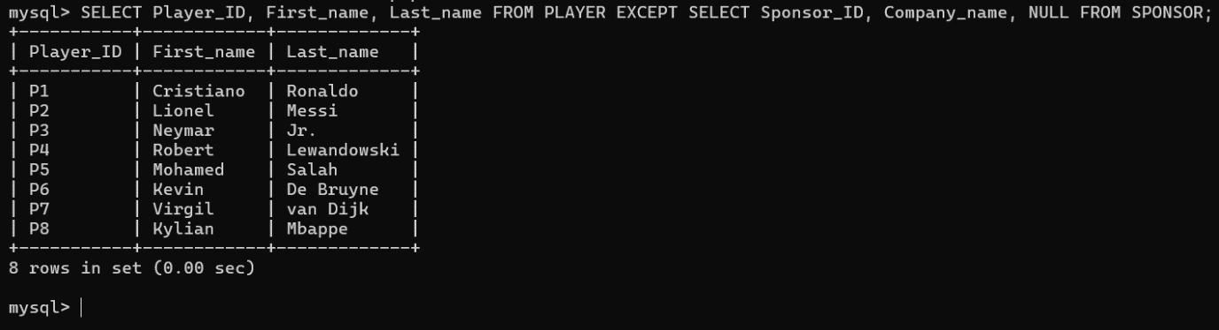

Figure 4.12: Set Difference.

* Division

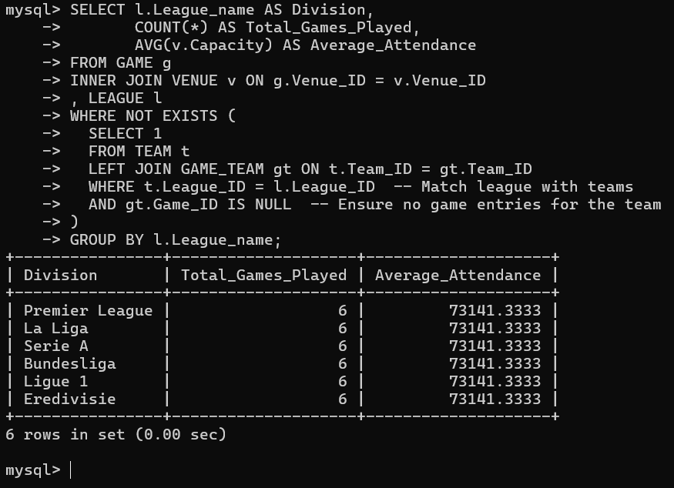

Figure 4.13: Division.

* Inner join

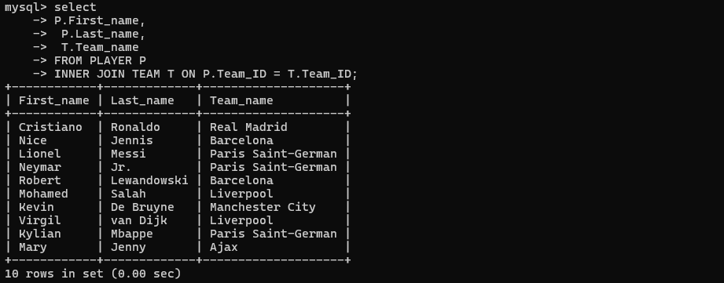

Figure 4.14: INNER JOIN.

* Natural join

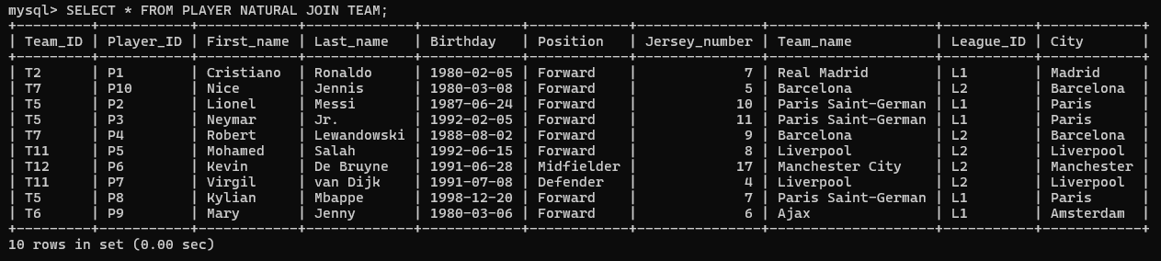

Figure 4.15: NATURAL JOIN.

* Left Outer Join

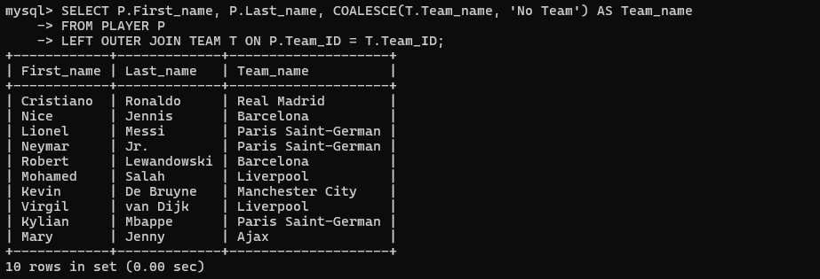

Figure 4.16: LEFT OUTER JOIN.

* Right outer join

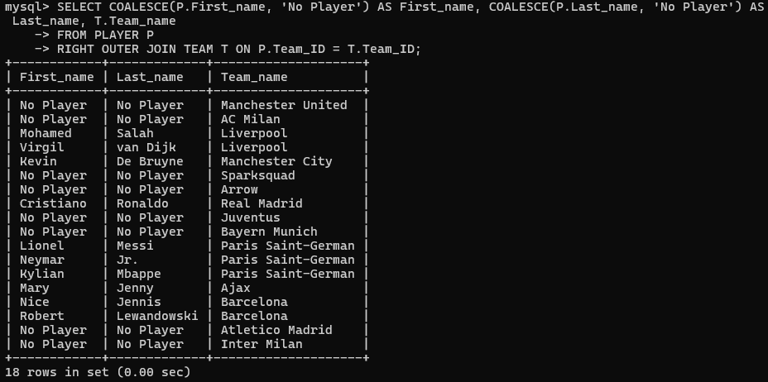

Figure 4.17: RIGHT OUTER JOIN.

* Full Outer join

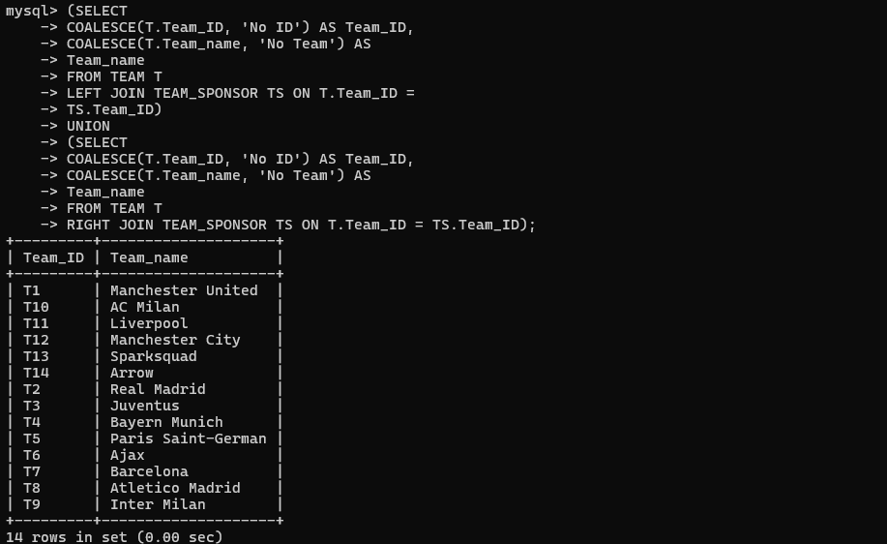

Figure 4.18: FULL OUTER JOIN.

* Outer union

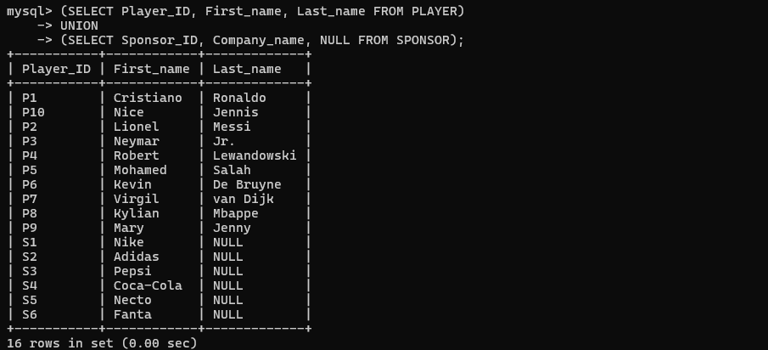

Figure 4.19: OUTER UNION.

* Nested query -1

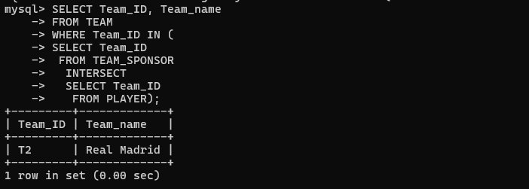

Figure 4.20: Nested Query - I.

* Nested query 2

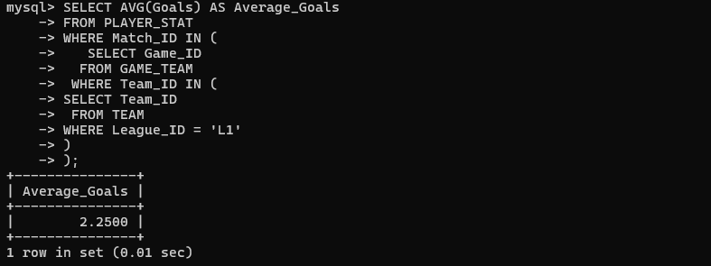

Figure 4.21: Nested Query - II.

* Nested query -3

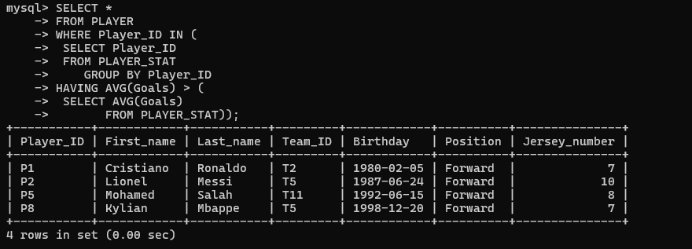

Figure 4.22: Nested Query - III.

# Tuning

The tuning of a query may be determined by comparing the amount of data accessed in the explanation table before and after an appropriate index was established. If the number of rows accessed decreases after an index is established, we may say that the query is tuned correctly. All of the screenshots in the list below satisfy that criterion.The following steps are utilized in query optimization for each difficult query to ensure a clear understanding.

* Remove any externally built indexes that are currently present in utilized tables. o
* After creating a proper index, display the number of accessed rows. (using EXPLAIN command)
* Display the number of rows accessed before creating a suitable index. (using EXPLAIN command)
* Display table indexes before creating a suitable index. (using SHOW INDEX command)
* Show table indexes after constructing an appropriate index. (using SHOW INDEX command)
* Union tuning



* Inner Join tuning
* Left outer join tuning
* Right outer join tuning
* Outer union tuning
* Division tuning
* Nested query 3 tuning
* Intersection tuning
* Set difference tuning
* Tuning nested query 1